**PH1213 Presentation**

Name- Ameya Kherde

Roll Number- 20211137

Batch- 5

**Question**- What is the energy and potential associated with thin spherical shells and how does it change on fitting one shell inside another? What are its real world applications?

Single Shell-

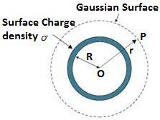

First, lets consider a conducting shell with charge +q and radius R. Using Gauss’ Theorem,

ʃall surface E da = q/ԑo

We see that the **field** inside the shell is 0 while the field outside is-

E = (1/4πԑo) (q/r2) (r > R)

Where,

ԑ = The electric permittivity of free space

r = distance from the centre of the shell

And the **potential** outside the shell is

V = (1/4πԑo)(q/r) (r > R)

While inside the shell we have

V = (1/4πԑo)(q/R)

Calculating the **Work** done in setting up the system-

W = (ԑo/2) ʃE2dτ , limits from R to infinity.

Where dτ is an infinitesimally small volume (volumenal).

W = (ԑo/2) ʃʃʃ E2r2Sinθdθdϕ , where the limits are 0 to 2π for ϕ, 0 to π for π and 0 to infinite.

W = (ԑo/2)(1/4πԑo)2 ʃ (q2/r4)r2(2)(2π)dr

W = (1/8πԑo) ʃ(q2/r2)dr

W = (1/8πԑo) q2[0 – 1/R]

W = q2/8πԑoR

Note that the Integral runs over all of space as the electric field extends until infinity.

Concentric Shells-

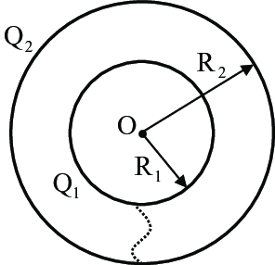

Let us not consider two concentric spheres with radii R1 and R2 (R1 > R2). Let the inner sphere have charge +q and the outer sphere have -q.

**Field** inside shell 1 by gauss’ law would be 0 as no charge is enclosed. Field outside shell two would be 0 as well since the enclosed charge adds up to 0.  
 ʃall surface E da = (-q +q)/ԑo = 0

Meanwhile, the field in the region between the shells is

E = (1/4πԑo) q/r2

The **potential** outside the shells would be-

V = (1/4πԑo) ( -q +q)/r = 0

In between the shells-

V = (1/4πԑo) [(-q/r) + (q/R1)] where R2 < r < R1

Inside the shells-

V = (1/4πԑo) [(-q/R2) + (q/R1)]

Finally, the **work** done in setting up this system-

W = (ԑo/2) ʃE2 dτ , limits from R2 to R1

Since the electric field is present only between R2 and R1, even if integral is done for all space, its as good as doing it for the space between the shells.

W = (ԑo/2) ʃʃʃE2r2Sinθdrdθdϕ , where the limits are 0 to π for θ, 0 to 2π for ϕ and 0 to infinite for r.

W = (ԑo/2) ʃʃʃ(1/4πԑo)2q2/r2Sinθdrdθdϕ

W = (ԑo/2) ʃ(1/4πԑo)2q2/r2(2)(2π)dr

W = (1/8πԑo) ʃq2/r2dr

W = (1/8πԑo) q2[1/R1 - 1/R2]

W = q2/8πԑoR1 - q2/8πԑoR2

Comparing the Work done for a single shell and for two shells with opposite charges, we see that the latter case needs lesser work to assemble. This is because the fields of the shells cancel each other in the region outside the shells.

The above case could be generalised for any charges as follows-

W = ʃ(E1 + E2)2dτ

W = ʃ(E12 + E22 + 2E1E2)dτ

W = ʃE12dτ + ʃE22dτ + ʃ2E1E2dτ

W = W1 + W2 + ʃ2E1E2dτ

Here W1 and W2 are the energy associated with the individual shells. Whereas, ʃE1E2dτ is the difference in energy between separate shells and the combined system, in other words, it’s the energy required to bring together the two shells.

Since in this case, E1 and E2 have opposite signs, hence the entire term is negative and thus the energy of this system is less than the energy of individual shells. If the shells had the same type of charge (both +ve or -ve), Then the term ʃE1E2dτ would be positive and the combined energy would be greater than the energy of individual shells.

As for potential, since R1 > R2, V1 < V2.

**Applications-**

The above shows us that energy can be trapped in between two charged shells, in fact, this is true not only for spheres, but also for other shapes. This is the principle behind a capacitor, two surfaces with opposite charges with energy trapped in between them. The material between the surfaces can be varied to change the value of ԑ and thus the properties of the capacitor. Capacitors have a wide array of applications in electric circuits and electronics.

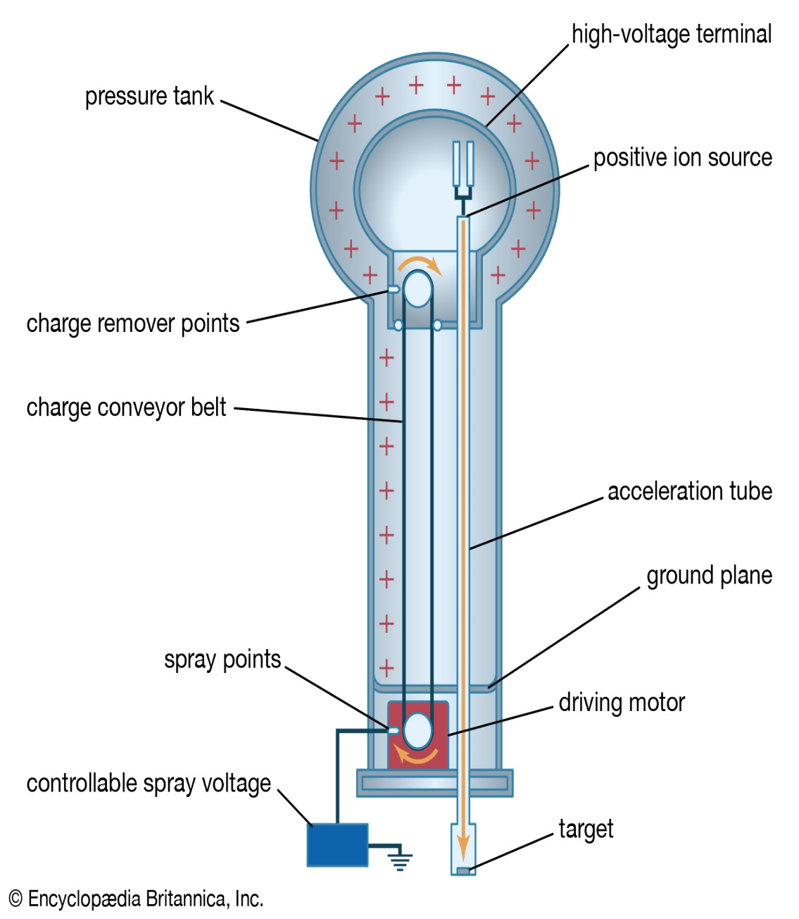

Another interesting device we come across is the Van De Graaff generator. It consists of two concentric spherical shells, which as seen above, always have a potential difference due to difference in their radii. If the shells are connected with a wire and any charge is added to the inner shell, it flows to the outer shell. This can be used to generate massive static potentials. Van De Graaff generators were used to create potentials for particle acceleration before the invention of the cyclotron.

**(Inspired by Problem 2.36, Page no. 97 of David J Griffith’s *Introduction to Electrodynamics*)**